How to read Books at home using Bookshare?
PC Computer | 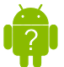  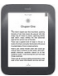  Nook and Droid Devices | 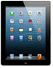  iDevices
Install Web Browser: Google Chrome  Create a Google Account | Device: Nook  Create a Google Account | iDevices: iPad, iTouch, iPhone
Install: Bookshare Web Reader Extension | Install App : | 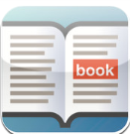  Install Read2Go App:
Bookshare: Sign up for an individual account | Bookshare: Sign up for an individual account | Bookshare: Sign up for an individual account
Bookshare: Create Bookshelves in Bookshare | Download Books: From Go Read App | Download Books: From Read2Go App
Bookshare: Add books to bookshelves

Bookshare: Select Read now in your Bookshelf

Cost: Free | Cost: Device | Cost: Device and App

Resources:

Video on how to use Google Chrome to read Bookshare books:

Bookshare Google Chrome Hangout - Full Recording

Video on how to read Bookshare books using the Read2Go App:
Read2Go

Bookshare Training Materials:
Bookshare Traininng

