Name: ______________________ Date: ____________ Teacher Name________________

**Mrs. Greif’s Counseling Self- Referral Form**

I would like to speak to you because my problem is a **(circle)…**

 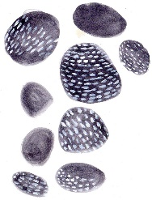 [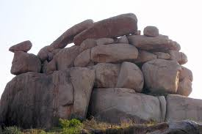](http://www.google.com/imgres?imgurl=http://mw2.google.com/mw-panoramio/photos/medium/22878318.jpg&imgrefurl=http://www.panoramio.com/photo/22878318&h=333&w=500&sz=47&tbnid=sQx67QHj74skiM:&tbnh=87&tbnw=131&prev=/search?q=images+of+boulders&tbm=isch&tbo=u&zoom=1&q=images+of+boulders&usg=__XaTSOYdBvgQj-8A0x6Tviqdqlpg=&docid=KpDZhHUzsPU30M&sa=X&ei=gGbMUbrhF7Td4AOnpoHADA&sqi=2&ved=0CDIQ9QEwAg&dur=631)

**Pebble Rock Boulder**

**Details about what I want to talk to you about (Check one):**

___ Family ___Friends  ___ My Feelings ___School ___ Other 

Name: ______________________ Date: ____________ Teacher Name________________

**Mrs. Greif’s Counseling Self- Referral Form**

I would like to speak to you because my problem is a **(circle)…**

  [](http://www.google.com/imgres?imgurl=http://mw2.google.com/mw-panoramio/photos/medium/22878318.jpg&imgrefurl=http://www.panoramio.com/photo/22878318&h=333&w=500&sz=47&tbnid=sQx67QHj74skiM:&tbnh=87&tbnw=131&prev=/search?q=images+of+boulders&tbm=isch&tbo=u&zoom=1&q=images+of+boulders&usg=__XaTSOYdBvgQj-8A0x6Tviqdqlpg=&docid=KpDZhHUzsPU30M&sa=X&ei=gGbMUbrhF7Td4AOnpoHADA&sqi=2&ved=0CDIQ9QEwAg&dur=631)

**Pebble Rock Boulder**

**Details about what I want to talk to you about (Check one):**

___ Family ___Friends  ___ My Feelings ___School ___ Other 