Repetitive Stories for Young Children
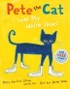Pete the Cat: I love my White Shoes by James Dean and Eric Litwin Pete the Cat is walking down the street in his white shoes which change colors as he steps in piles of strawberries, blueberries, and mud. He doesn't let his colorful shoes get him down, he keeps singing his song... his very repetitive song! https://www.youtube.com/watch?v=QfE5X-bn3uU
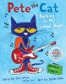Pete the Cat Rocking in My School Shoes by James Dean and Eric Litwin Pete the Cat is hot, hot, hot with preschool children. In this story, he is rocking a new school year as he sings his school song... his very repetitive school song! https://www.youtube.com/watch?v=0qjOVw-v3d4
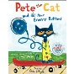Pete the Cat and His Four Groovy Buttons by James Dean and Eric Litwin Once more, Pete the Cat faces the challenges of life as he loose buttons off his shirt. Does he cry? Goodness NO! He keeps singing his song...his very repetitive song. https://www.youtube.com/watch?v=X7va0beuK584
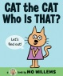Cat the Cat Who is That? by Mo Willems. Another hot item is any book by Mo Willems. Many of them lend themselves so well to young learners actively participating in the reading of the story. Cat the Cat is one of the most obvious repetitive texts. Cat the Cat moves through the book introducing us to a whole cast of characters.
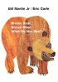Brown Bear Brown Bear by Bill Martin and Eric Carle This classic book follows a pattern on each page as each animal introduces the next animal in the story. "Brown bear, brown bear what do you see? I see a red bird looking at me." The red bird picks up the pattern on the next page and continues the pattern throughout. https://www.youtube.com/watch?v=0qjOVw-v3d4
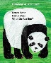Panda Bear Panda Bear by Bill Martin and Eric Carl This book continues the pattern from the Brown Bear book. This is a nice way to help children transfer the knowledge from one book to another and firm up their knowledge. This book focuses on endangered animals..
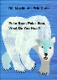Polar Bear Polar Bear what do you hear? by Bill Martin and Eric Carl This book also continues the pattern of the previous books but it focuses on animal sounds.
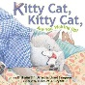Kitty Cat, Kitty Cat are you Waking Up? by Bill Martin Jr. This book has a repeating pattern and a rhyming text. It is a little cutesy but my kids love this little kitty who doesn't want to wake up and get ready to go!
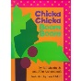Chicka Chicka Boom Boom by Bill Martin Jr. A rhyming stories of letters racing up a coconut tree is interspersed with a repetitive jingle. Kids can't help but join in the silly sounding words in this book. http://www.youtube.com/watch?v=dEUp6BPm6pM&list=PLCBC18B4C170E0CFD
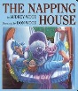The Napping House by Audrey and Don Wood As a child, a cat, a dog, a mouse and a flea pile into bed with a sleeping Grandma in this story, the reader gets to experience a predictable pattern of text. http://www.youtube.com/watch?v=YAoofBOhPHw&list=PL5pfNvvOiV6H8vedqKRgdUJR8CbRN2uUV
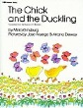The Chick and the Duckling by Mirra Ginsburg When a duckling is born moments before a baby chick, the chick admires the older duckling and copies each of his actions with a repetitive "me too". The ending of this book is a fun surprise for kids!
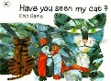Have you seen my cat? by Eric Carle In this story, a little boy loses his cat and travels the world asking "Have you seen my cat?" The repetitive phrase, "This is not my cat" will be wonderful for children to chime in.
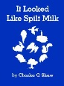It looked like Spilt Milk by Charles G. Shaw In this story, a white shape on a blue background changes with each page turn. The repeating phrase, "It looked like..." allows children to join in on a guess. This is one your child will be able to "read" independently long before they can actually decode text.
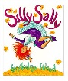Silly Sally by Audrey Wood Silly Sally and her friends parade into town in this cumulative rhyming text. http://www.youtube.com/watch?v=js1FWVLOZNo
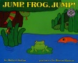Jump, Frog, Jump by Robert Kaplan This is a cumulative tale of a frog who tried to catch a fly but then found himself in the place of the prey. He escapes many attempts at being eaten when readers shout, "Jump, frog, Jump!"
Repetitive Texts that will engage your child's emotions: When your child reads the repetitive phrase in these books, they are able to express the characters emotions. It's a safe way for your child to express being grouchy, mad, or scared!
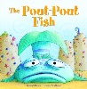Pout Pout Fish by Deborah Diesen The Pout Pout fish is a gloomy member of the underwater world. His friends swim along and try to get him to give up his gloomy ways. To each encourager he offers the same repeating refrain, "I'm a pout pout fish with a pout pout face for spreading dreary wearies all over the place. Blub, blub, blub." Eventually, someone comes along that helps him turn his frown upside down.
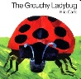The Grouchy Ladybug by Eric Carle While this book does focus on a grouchy ladybug who thinks he is big stuff and wants to stir up fights, it allows children to join in expressing a phrase they have all felt. They are able to sassily say, "Oh yeah, want to fight?" in a safe environment.
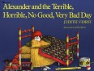Alexander and the Terrible, Horrible, No Good, Very Bad Day by Judith Viorist This is a longer text embedded with the repetitive text, "It was a terrible, horrible, no good, very bad day." The story is one that children (and adults) can relate to. Reading the book can be almost therapeutic. http://www.youtube.com/watch?v=Ezbssw11724
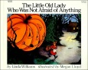The Little Old Lady Who Wasn't Afraid of Anything by Linda D. Williams In this book, children repeat the sounds that a little old lady hears in the woods. The suspense in this book builds, but the ending is funny rather than scary!
Repetitive Nonfiction Text: Every collection should have some nonfiction.
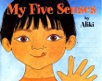My five senses by Aliki This book explores the five senses. Several of the pages have a repeating pattern and your child will love to try and read these pages.

