World Book – Early Peoples
The perfect database to use for your 6th grade Ancient Egypt project!
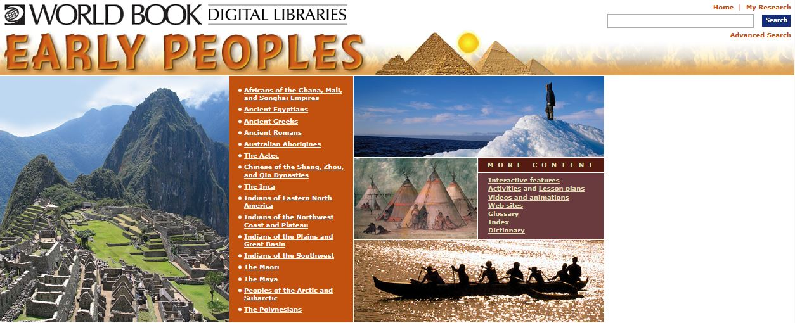

You can find this database on the RFMS Media Center webpage: Online Resources
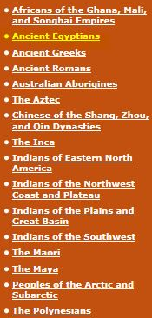
Click “Ancient Egyptians” found in the central orange column.

The Table of Contents will load:
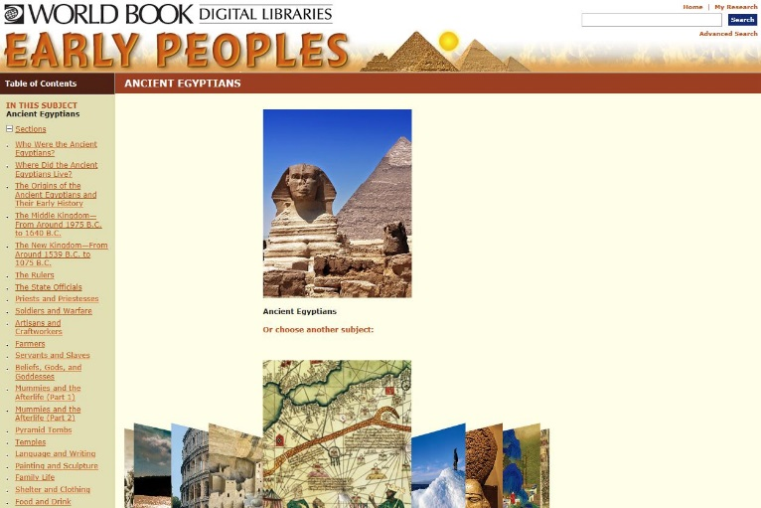

Now we are ready to RESEARCH!

You can use the Table of Contents (on the left) or the Search Box (upper right hand of screen) to conduct your search.
Type in your keyword
Click Search or press Enter

You will see a list of articles, click one whose description interests you.
On the article page you will find:

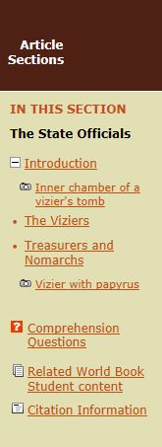
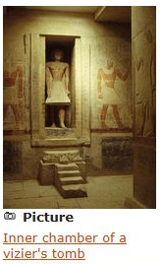
Article Sections –
Click to navigate to particular sections of the article

Tool Box – Print, Email, Save, Text to Read,
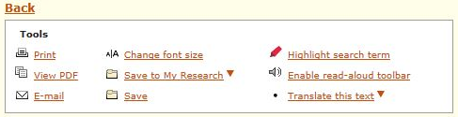
and Translate options

Pictures – Captions are
hyperlinked for more information

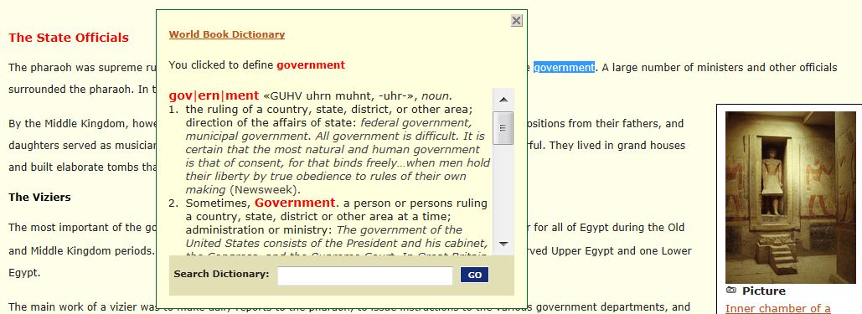
Dictionary – double click on any word to see the dictionary definition

Glossary – hover over an underlined word to see the glossary terms

Content Standards – allows students and teachers
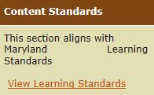
to see how articles relate to curriculum content standards

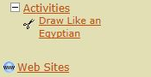
Activities – Further enrichment opportunities

Links to related Student Content –
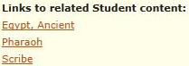
for further research

Citation Information – MLA, APA, and Harvard formats for the article, plus citation tips
