Library/Media Center
Earle B. Wood Middle School

How to Avoid Plagiarism with Parenthetical Documentation

Based on the format from the Modern Language Association (MLA) as presented in Write Source publications, Write Source 2000: A Guide to Writing, Thinking and Learning (1999), page 229, (used at Wood MS) and Writers INC: A Student Handbook for Writing and Learning (2002), pages 255-265, (used at Rockville High School).

Frequently Asked Questions

1. What is "parenthetical documentation"?
It is like a footnote at the bottom of a page or endnotes at the end of a chapter or a book or an article that tells your reader the source material you quoted or paraphrased or the idea that you borrowed to write your paragraphs.

2. Why do I need to do this?
Mature researchers are ethical, honest users of information. They do not copy words or ideas from resources, use them in their projects, and try to make the reader think it is their own writing/information. If you knowingly or unknowingly use material, including graphics of any kind, and do not give proper credit to the source, you are plagiarizing the material. Plagiarism is a form of cheating and appears in the school's discipline code with negative consequences.

3. How then do I document my source?
Usually within a sentence, before the before the period, the writer puts into parenthesis the following: author, if known, the page number of the source or print out. If there is no author, cite the title of the source and the page number of the source or print out. If it is a web site, use author or title as just described; NEVER write the URL (electronic address) in a parenthetic citation. After the page number, close the parenthesis and add a period to end the sentence and the citation.

4. Where do I get the information for my documentation?
When a researcher takes notes using the 3 part format: search term at the top, note--words copied from the original using quotation marks or words paraphrasing the original, and the author or title and page number at the bottom of the card, the writer can insert the citation as he/she writes. (Do not go back and add citations after you have written the paragraph; you will forget to do it or make mistakes. Do it as you compose your sentences.)

5. How do I understand the relationship between the citations and the bibliography or works cited? Because the bibliography or works cited entries are in alphabetical order, the reader can easily pick up the author's name or the first word of the title to (a) see that the writer is an ethical user of information and (b) see the source of the writer's material for further reading or verification.

Sample Paragraphs with Parenthetical Documentation

Some of the physical characteristics of the white-tailed deer include weight, coat, tail, and antlers. These deer vary in weight. The males or bucks are usually larger than the females or does (Patent 10). In the northern part of their habitat the bucks can weight about 400 pounds. In the southern parts they weigh about 220 pounds. The small ones in the Florida Keys weigh only 80 pounds (Patent 29-30). Their coats vary in color from season to season. In summer it is a golden-reddish brown, and in the fall and winter it is grayish and "blends in with dead grass and muted colors of the forest" (Patent 28). The young have white spotted coats "that help camouflage them in the dappled light of the forest or in tall grass"(Patent 10). Adults during all seasons have white fur on their bellies, rumps, faces, necks as well as the underside of their tails (Patent 28). The tail is one foot long (Patent 27), and they carry it raised when running ("Mule Deer" 1674). When male deer are about four years old, they have developed antlers that are divided into two equal branches and curved forward at the head ("Mule Deer" 1674). Some does, about 1 out of every 1000, however, develop simple, small antlers, ("White-tailed Deer" 2).
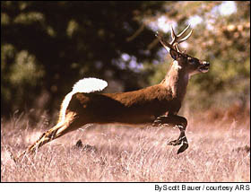
White-tailed Deer: Buck on the Run Flashing His Tail
Photograph by Scott Bauer

Antlers have some special characteristics. They are made completely of bone, and they fall off the animals' head every year (Nams 18). "Most antlers fall off in late winter or spring" (Nams 19). When they start to grow again in the spring, they "sprout from short knobs called 'pedicels'"(Nams 18). "While growing, the antlers are covered with soft fuzzy skin called 'velvet.'. . . [which] has lots of blood vessels" (Nams 129). The blood carries calcium to the antlers, which helps them grow, but after 4 to 7 months the velvet dries up, and the antlers stop growing (Nams 19).

Additional physical characteristics are the eyes, ears, nose, legs, and hooves. Deer have long, narrow heads with eyes located on both sides of the head, which enable them to see more around them while grazing. They cannot see shapes very well, but they can detect movement very easily (Patent 18). The ears are on top of the head and can turn independently to pick up sounds from any directions. Their noses have a sharp sense of smell that allows them to pick up scents of danger from upwind. Their noses also contain scent glands that are used to communicate with other deer (Patent 18). Although they have long, slim legs without much apparent muscle, their strength comes from muscles contained in the body. The foot of the deer has two toes covered by hard, bony material called "hooves." These two-toed hooves are called "cloven" (Patent 20). All of these physical features help make them adapt to their habit.

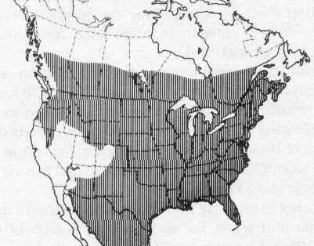

Map Depicting the Range of the Whitetail Deer
Map by Stu Keck

Bibliography or Works Cited
(This list will appear on a separate page of a report. It is shown here for convenience.]

Bauer, Scott. Photograph. "Deer Compensate for the Deer-slayers." 18 November 2001 Environmental News
Network.24 June 2003. <http://www.enn.com/enn~news~archive/2000/>.

Keck, Su. Map. North American Game Species. n.d. BowHunting on the Net. 25 June 2003.
<http://www.bowhunting.net/NAspecies/whitetail.htm>.

"Mule Deer." International Wildlife Encyclopedia. V. 15. New York: Marshal Cavendish, 1994.

Nams, Magi. "Horns and Antlers." Ranger Rick. November 1994: 18-27.

Patent, Dorothy Hinshaw. Deer and Elk. New York: Clarion Books, 1994.

"White-tailed Deer." Hinterland Who's Who. 1989. Canadian Wildlife Service. 24 June 2003.
<http://www. cws~scf.ec.gc.ca>. Richard S. Huffman, LMS, 6/03

