History Hike – Skycroft Conference Center
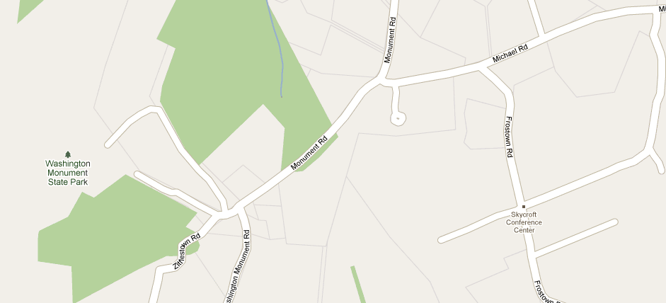
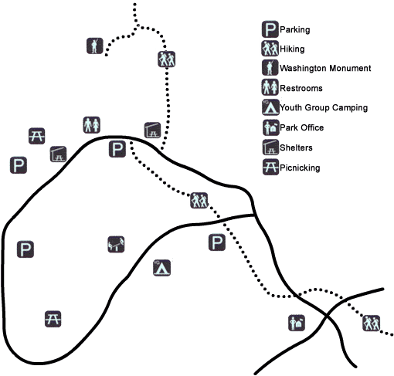
Hiking directions from Skycroft Conference Center to Washington Monument State Park:
Exit camp and turn right onto Frostown Rd. Turn left onto Michael Rd. Turn left onto Monument Road. As you approach Washington Monument Rd. you will see a white blazed trail head off into the woods on the right. Follow this trail to the State Park. You will cross the road twice and end in the parking lot. Continue from the parking lot up the trail to the monument. You may also walk along the road instead of the trail.

Timing and Lesson
The hike should take about 45 minutes each way, with time for investigation at the park. It is possible to contact the park in advance to have the museum open and/or interpreter available. More information can be found on the Washington Monument State Park website and more history information can be o found on the nearby South Mountain State Park website:
http://www.dnr.state.md.us/publiclands/western/washington.asp
http://www.dnr.state.md.us/publiclands/western/southmountain.asp

Safety
Orange safety vests are available so students are visible on the roads. Please ask your coordinator to leave these out.
Please keep students on the side of the road at all times. One teacher should lead the hike and another should bring up the end of the line. Each should have a walkie talkie.

