Watershed and Forest Survey Data Sheet Time to Return: ______________ Group # _______

Pole  &  Name on Pole | Describe the layers of the forest in this area.  How many and what kinds of plants do you see?  What does the forest floor look like? | What resources are available to wildlife like shade, food, shelter, water, etc.? | List the wildlife you see (birds, mammals, insects, fish, etc.) or signs of wildlife like scat, tracks, burrows, etc. | List signs of human impact like roads, trash, buildings, foot traffic, etc.  What possible sources of pollution are nearby like houses, trash, pipes, farms, gardens, lawns, etc.?

Reflect: Is the land in good condition to protect water bodies nearby?
If you have extra time, choose other poles to visit. Record the name on the pole. Make sure to be back on time!
What Does a Healthy Forest Look Like?
A healthy forest is a complex, interdependent community of plants, animals and soil. Each layer of the forest provides diverse habitats and helps to protect clean water. A healthy forest should have the following layers:
- The canopy is the forest's top layer. It shades and protects animals and plants below, while also intercepting and slowing rainfall.
- Beneath the canopy is the understory, a second layer made up of smaller trees and shrubs.
- The next layer, the forest floor, is populated by vines, grasses, mosses, worms, insects, fungi, bacteria and other small plants and animals. They continually decompose leaves, wood and other organic material that falls to the forest floor so that it may be reused by larger plants. This layer is also a storehouse of nutrients.
- The litter on the forest floor protects the soil, the bottom layer of the forest. Healthy forests often contain more living biomass in the soil below ground than on the surface.
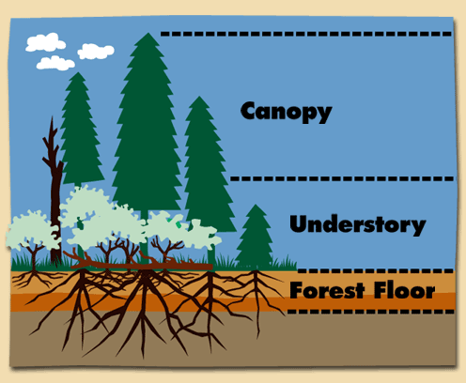
Pole | Name on Pole
Soil

