**Principal Intern’s Message**

In ThIS issue:

Dear GES Families,

Principal Intern’s Message 1

Dates to Remember 1

PTA News 5

Patriot Student of Month 7

MCPS News/Imp Info 8

Happy December! Mrs. Bryan and I certainly hope you had a wonderful Thanksgiving. There is so much to be thankful for! Thanks to our PTA for organizing the Read-a-thon and to 50 of our families for sponsoring their child/ren in this effort to raise about $2,300 for the PTA and its programs. We want to thank our **community partner, Agape AME Church,** for providing 19 Thanksgiving baskets to identified GES families. The baskets were each filled with a frozen turkey, an oven roaster, frozen tilapia filets, fresh produce and canned/boxed goods allowing our families in need to have a “traditional” Thanksgiving meal. What a blessing for those families! Again, we have so much to be thankful for.

As you know, over the past five months, I having been working side by side with Mrs. Bryan to refine the skills I developed over the years prior to coming to GES and developing a high level of ownership in the work that is occurring at GES each day. **Beginning January 2 through February 22, 2019**, as part of my administrative development and internship, I will be assuming full responsibility of GES as the **Acting Principal**. During this time, Mrs. Bryan will serve as a Visiting Principal supporting the Principal Intern/Acting Principal at Julius West MS while Deborah Ryan, Principal at Rosemary Hills ES, will serve as our Visiting Principal here at GES. I am looking forward to this next step in my internship process and I am grateful to have Mrs. Bryan as my Principal Developer and to be leading with her. Please also note that during the month of December, I will be assuming more of Mrs. Bryan’s responsibilities so that I am fully prepared to take the role of Acting Principal. If you have any questions, please feel free to email or call either Mrs. Bryan or myself.

The week of January 2-4, 2019**,** the **Montgomery County Mobile Science Lab** will be housed on the grounds of GES. This mobile science lab will provide hands-on learning opportunities to all our students. We would like to extend a special thank you to Ms. Marino for coordinating this effort with our staff, the science lab volunteers for guiding our students

*Continued on pg 2…*

**Germantown Elementary** 19110 Liberty Mill Road Germantown, MD 20874 Phone: 301-353-8050

**GES Website** Montgomeryschoolsmd.org/ schools/germantownes/

Contact: Jaime Howenstein

[jaime_b_howenstein@mcpsmd.org](mailto:jaime_b_howenstein@mcpsmd.org)

Listserv: Join and stay up-to-date! To sign up, send an email to GES-PTA [subscribe@yahoogroups.com](mailto:subscribe@yahoogroups.com) or click the Join button on our website [www.ges-pta.org](http://www.ges-pta.org)

**Patriot Newsletter Editor:**

Kris daCosta-Warshauer [KdacW35@gmail.com](mailto:KdacW35@gmail.com)

MC900001544[1]

*Principal Intern’s Message continued …*

**Dec 5** PTA restaurant fundraiser @ Ledo, all day

**Dec 12**  Colgate dental van visit

**Dec 13**  First grade field trip to Black Hill Nature Center, 11:45 am – 2:30 pm

**Dec 13** Interims go home

**Dec 17** Interact Story Theatre: ***Voytto Tech: a scifi fable***

**Dec 24-28** Winter Break – schools closed

**Jan 1st**  New Year’s Day – schools closed

**Jan 2nd** School resumes

**Jan 2-4** Mobile Science Lab at GES

**Jan 3rd** PTA meeting, 7 – 8:30 pm

**Jan 4th**  GES Spirit Wear Day

**Dates to Remember**

through this unique learning opportunity, and the Maryland Agriculture in the Classroom program for their generous funding (grant) that made this opportunity a reality!. We are excited for all our students to engage in this wonderful experience!

From time to time, we will highlight information contained within the **GES Policies and Procedures** document that was distributed at the beginning of the school year and is posted on our school’s website. The section on **discipline issues** is highlighted below:

*Misunderstandings between children occur from time to time. Our school staff work to resolve issues in a quick and efficient manner when these issues are brought to our attention.*

*If your child is involved in a situation, in class, a parent should notify the teacher. If there is an issue that occurs on the bus or at lunch/recess or any other areas of the school (and its grounds), please contact the principal. A thorough investigation (with witnesses if applicable) will take place to determine the series of events and follow-up/ consequences. Please note, the staff or administrators cannot inform parents of another child’s consequences due to confidentially issues. A comprehensive school behavior management plan is sent home at the beginning of each year that is in keeping with the MCPS Code of Conduct.*

*We continue to implement PBIS (Positive Behavioral Intervention and Supports). PBIS is a guide for creating safer and more effective schools by building an encouraging environment through positive disciplinary practices. The 3 behavioral expectations that GES focuses on are: (1) Be Responsible, (2) Be Respectful, (3) Be Safe...that’s the Germantown way! Positive behavior expectations are posted throughout the building, which are directly linked to our 3 behavioral expectations. Staff will continue to use them as a tool in teaching our students the expectations in each location of the school building. To find out more information about PBIS visit:* [*http://www.montgomeryschoolsmd.org/departments/studentservices/mentalhealth/default.aspx?id=333017*](http://www.montgomeryschoolsmd.org/departments/studentservices/mentalhealth/default.aspx?id=333017)*.*

*Student behavioral concerns should first be addressed by your child’s teacher. *More serious concerns in grades K, 2 & 4 should be addressed to Mrs. Walsleben, Principal Intern, while grade 1, 3, & 5 concerns should be addressed to Mrs. Bryan, Principal.*

*\*****Please note, January 2-Febrauary 22****,* ***concerns in grades 1, 3, and 5 will be addressed by Ms. Deborah Ryan, visiting principal.***

It is hard to believe we are already transitioning into 2019, but I guess time quickly flies by when we are focused on excellent teaching and learning! As we **enter into the winter holiday season,** we would like to take this time to wish you all well and to thank you for your ongoing support and kindness toward our staff and us. We look forward to more good times after the New Year! Please call (301- 353-8050) or email us ([Amy_D_Bryan@mcpsmd.org](mailto:Amy_D_Bryan@mcpsmd.org) or Carolynn_Walsleben@mcpsmd.org) if you have a question, comment or concern.

Take care,

Carolynn Walsleben & Amy D. Bryan

Principal Intern & Principal



GES Restaurant Fundraiser!

Take a break from the holiday shopping by treating yourself and your family at Ledo Germantown. Ledo will donate a % of sales to the PTA.

Monday, December 5

ALL DAY

Follow Mrs. Bryan on [](https://www.google.com/imgres?imgurl=http://cnet2.cbsistatic.com/hub/i/2012/06/06/b8ba2ec1-fdb6-11e2-8c7c-d4ae52e62bcc/2f74add282f3095513ce5eee2d150cac/FDNews_newtwitterlogogrey.jpg&imgrefurl=http://www.cnet.com/news/twitter-introduces-ticker-symbol-cashtags-for-finance-searches/&docid=VL65mvfKlXuOlM&tbnid=-ULM1Az90yvrQM:&w=300&h=214&ei=vlAkVPOTFoOiyATKuYD4CA&ved=0CAIQxiAwAA&iact=c) *@TeamGermantown1*



**Earn money for GES!**

**Collect and bring Box Top labels**

**to your child’s teacher!**

**Additional School News**

Food safety alert: Romaine Lettuce update for MCPS

On Tuesday, December 4, 2018, schools began to receive romaine lettuce that can be used because it has been harvested from other areas of the United States NOT affected by the outbreak.  The e-coli outbreak has been traced to romaine lettuce harvested from the Central Coastal growing regions of northern and central California.  The Centers for Disease Control (CDC) is now reporting that romaine lettuce from other parts of the United States and Mexico is safe to eat.

MCPS received information from our fresh produce supplier, that they will only sell, process or ship romaine lettuce from areas other than California and that they will not process, sell nor ship any romaine lettuce that does not have a harvest date of 11/23/18 or later.  Romaine lettuce being delivered to schools starting on Tuesday, December 4th is safe to consume.

Note from Mr. Burdette (updated): Jump Rope for Heart

 Our 25th Annual Jump Rope for Heart was a huge success! On Wednesday, Nov. 21st we had approximately 125 jumpers participating in 2 different jumps. We had about 45 students from 1st and 2nd grades in the first jump and about 65 students from 3rd, 4th and 5th grades in the second jump. All of the jumpers enjoyed the music and different jumping activities that were provided. As of date, Germantown Elementary has collected approximately $3,800 dollars for the American Heart Association. Mr. Burdette still has a few students who have not turned in their pledge sheet. He is asking to get all the pledge sheets turned in so he can order the prizes earned and turn in all the money. If your child still has a pledge sheet that has not been turned in, please do so by **Friday, December 7, 2018.**

Great news happening at GES:

**Baby news:** Welcome to our newest GES family member, Jackson Elliot Brown! Mrs. Brown, our third grade teacher, and baby are doing very well, and we know, you, along with the GES staff would be excited to hear this wonderful news!

**Congratulations to our GES Crossing Guards:** We are very lucky to have two wonderful Crossing Guards, Ms. Lisa Brown and Ms. Ameline Flore Tedjio here at GES. Did you know that both women were nominated for America's Favorite Crossing Guard? We are looking forward to hearing who won, but for GES, Ms. Lisa and Ms. Flore are already winners! Please congratulate our Crossing Guards for their nomination and take a moment to thank them for always keeping GES students safe.

**State of Maryland Report Card:** For the first time since 2014, the Maryland State Department of Education released state report cards, which assigns each school a rating ranging from one star to a maximum of five stars.  Some of the factors used to determine the ratings include academic achievement on the Partnership for Assessment of Readiness for College and Careers (PARCC) tests, absenteeism and graduation rates, and access to a well-rounded curriculum.  
  
Congratulations Germantown ES Staff & Students! We earned **5 of 5 stars** with a percentile ranking of 84 due to our collaborative work! See the report card here:

<http://reportcard.msde.maryland.gov/Graphs/#/ReportCards/ReportCardSchool/3/17/6/15/0102/>

Events to mark your calendars:

**Colgate Van (free dental screenings) coming to GES:** on **Wednesday, December 12,** the Colgate Bright Smiles, Bright Futures dental vanwill greet GES students. During the visit, up to 100 students who returned an affirmative signed consent form will receive a free dental screening and will be taught how to brush, floss and the importance of eating healthy foods. Students that are signed up for screenings will miss a minimal amount of class instruction. Thank you to *Colgate Bright Smiles, Bright Futures* for making this service available to all GES students.

**Interact Story Theatre coming to GES:** **on Monday, December 17,** Interact Story Theatre, an educational theatre company that specializes in arts integration and STEM education will join us at GES for the production of ***Voytto Tech: a scifi fable.*** This interactive play combines science and technology with a story exploring the tough topics of trying to deal with bullying, peer pressure and social inequity.

***Voytto Tech: a scifi fable*** is an interactive performance designed for students in Kindergarten through 5th grade where the audience participates from their seats, becoming characters in the story and brainstormingideas in the show. **A special thank you to the PTA for providing funding and support in for this performance.**

**MoCo Comic Con Art Contest:** The Montgomery County Public Library is sponsoring a MOCO Comic Con art contest. Students K-12th grade are invited to submit a two dimensional drawing or painting no larger than 18’’ x 24’’. Draw or paint your favorite character or invent your own character!

You can get an entry form from Ms. Kennedy or from the bulletin board outside the art room. You can also go on line to <https://montgomerycountymd.gov/library/programs/mocomcon/cosplay.html>

Entries are due to Ms. Kennedy 12/18/18 or you can turn them in directly to any MC Library branch by 12/31/18. Good Luck to all our GES students!

[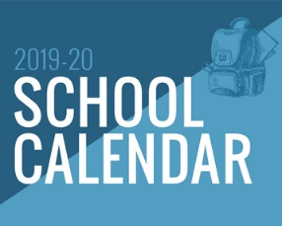](https://news.montgomeryschoolsmd.org/quicknotes/plan-ahead-2019-2020-school-year/)It is never too early to start planning! The Board of Education has approved the start and end dates for the **2019-2020 school year.** Plan ahead by accessing the link on the accompanying image.

Gifts to GES staff during the holidays:

Since we have many thoughtful and generous parents, we want you to know that gifts are not expected; however, we recognize and appreciate the desire to celebrate our staff for their dedication and hard work. Please be aware of the county ethics policy as you consider your recognition plans over the holidays and beyond. Staff members are not allowed to accept gifts from individuals valued over $20 for one occasion and $100 during the course of a full calendar year.

Traffic and Pedestrian Safety: *Cross the road at the pedestrian crosswalk!*

Please consider the safety of your child/ren, our students, parents, and staff by setting yourself as role models. When walking your child/ren to drop-off and from pick-up, *it is safer to walk on the sidewalks* leading to the marked crosswalks to arrive and leaving the GES school property.

**PTA News**

Dear Patriots Family:

Many thanks to all of those who participated in the Read-a-thon and to GES parent, **Melaku W**., who coordinated this event! Many kudos to **Becky M.** for her incredible work on the PTA website, and our editor **Kris** for all of her hard work preparing the Patriot newsletters each month. Our next member-wide PTA meeting will be on Wednesday, January 2, 2019 at 7:00 p.m. in the GES Media Center.

Ending this week on Friday, December 7, 2018 at 7:00 p.m. in the All Purpose Room, we are hosting a PTA Holiday Potluck Party for PTA members and their families. There is no cost for this event, we simply ask that you sign-up to bring a dish to share. If you are a PTA member whose family plans to attend and you have not received the Sign-up Genius link, please check the recent GES email blast. If you have not signed up to be a PTA member and would like to join the holiday fun, you may also e-mail PTA Membership Chair Tisha Chrobak [chrobaktisha@gmail.com](mailto:chrobaktisha@gmail.com) or me [LLydiarose@aol.com](mailto:LLydiarose@aol.com).



For our school and PTA, a holiday shopping wish list includes corporate donation from selected shopping vendors: Amazon, Giant Food, and CertifiKid. When you do your shopping at these vendors, Amazon, Giant, and CertifiKid supports our fundraising needs.

GES PTA has a special program through AmazonSmile! Amazon donates 0.5% of the price of your eligible AmazonSmile purchases to the GES PTA. AmazonSmile is the same Amazon you know - same products, same prices, same service. Support the GES PTA by shopping holiday gifts with a click on the logo on the left.

[](https://smile.amazon.com/23-7031179)

GES also has a great awards program through Giant. Through the [A+ School Rewards Program](https://giantfood.com/school-rewards/), Giant Food donates money to local schools. The program continues through March 2019. Customers register their Giant Card and can support up to two (2) schools. Sign in to your account (or register for an account) to link your Giant Card to your school. GES encourages you to do your grocery needs at Giant for holiday parties, holiday meals, and holiday cookies!

[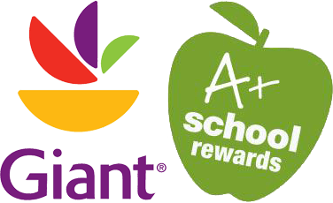](https://giantfood.com/school-rewards/)

[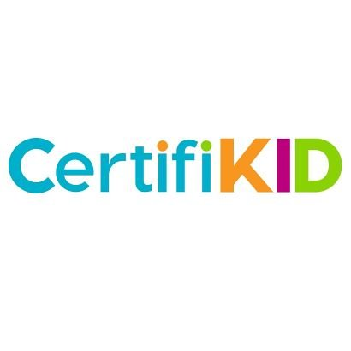](https://www.certifikid.com)

Need fun things to do during Winter Break? Jumping on indoor trampolines? Visit Mt. Vernon and tour 1800’s holiday decorations? Check out CertifiKid for deals on activities for you and your family! GES earns money for deals purchased through CertifiKid. Sign up for free on [CertifiKid.com](https://www.certifikid.com), and use promo code PATRIOTS at checkout.

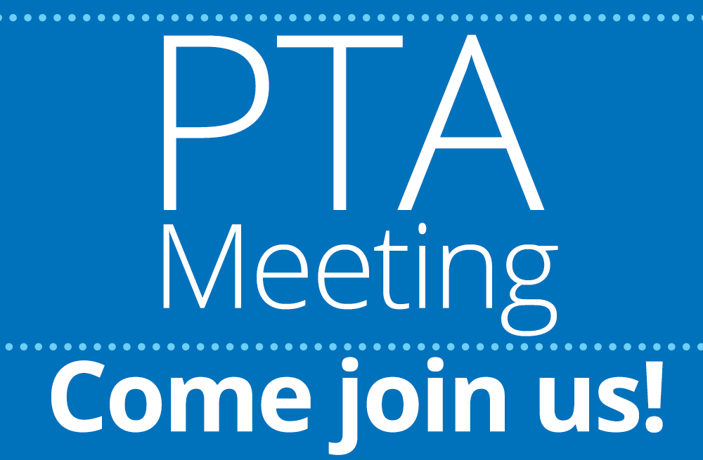

Our next member-wide PTA meeting is scheduled for Wednesday, January 2, 2019 at 7:00 p.m. in the GES media center. School reconvenes after break on that day.

Volunteer Tidbits

From Read-A-Thon coordinator **Melaku Wubshet**:

As you know, the Read A thon ended on 11/9. It was a success both in terms of having the kids read more, and raising money for the PTA to continue to support various social and educational programs. Thanks to the parents, teachers and everyone involved, we have over 13,000 minutes logged and raised $2,300!





Lastly, parent volunteers are needed on **January 2, 3 and 4** to volunteer during the full-day science labs that will be taking place on those days. If you have availability on any of those days, please e-mail me as soon as possible.

Wishing you and your families a safe and happy holiday season!

Sincerely yours,

Lydia Rose

GES President

[LLydiarose@aol.com](mailto:LLydiarose@aol.com)



Patriot Student of the Month

(November 2018)

|  |  |  |  |
| --- | --- | --- | --- |
| **Kindergarten** |  | **Fourth Grade** |  |
| *Mrs. Malek* | Jadon | *Mrs. Kahn* | Jaslene |
| *Mrs. Savino* | Kayla | *Mr. Kaigler* | Xavier |
| *Mrs. Wysong* | Darien |  |  |
|  |  |  |  |
| **First Grade** |  | **Fifth Grade** |  |
| *Ms. Horvath* | Daniel | *Mrs. Boucher* | Maya |
| *Mrs. Minehan* | Aisha | *Ms. Marino* | Aneesh Manik |
| *Mrs. Rockovich* | Aisha |  |  |
|  |  | **SCB** |  |
| **Second Grade** |  | *Ms. Farrell* | Mason |
| *Mrs. Booth* | Thea | *Ms. Gray* | El |
| *Mrs. Edmundson* | Isaac |  |  |
| *Mrs. Kissal* | Felix | PEP 5 Hour (*Mrs. Ho*) |  |
|  |  | PEP Classic (*Mrs. McKenzie*) |  |
| **Third Grade** |  | PEP Pilot (*Mrs. McKenzie*) |  |
| *Mrs. Brown* | Daniel |  |  |
| *Mrs. Lea* | Cadyn | Peacemaker of the Month | Natalie |
|  |  | Patrol of the Month | Nicole |



**Winter Coat Drive Under Way (English and Spanish)**

The Prekindergarten/Head Start Programs is seeking donations to provide students with new winter coats. They are collecting coats for boys and girls in sizes 5, 6, and 7, along with other winter wear, such as hats and gloves. Monetary donations are welcome. Donations can be sent to Rocking Horse Road Center, 4910 Macon Road, Room 141, Rockville, Maryland 20852. For more information, contact [Lisa Conlon](mailto:Lisa_W_Conlon@mcpsmd.org) at 240-740-4530.

**Está en Marcha la Campaña de Recolección de Abrigos de Invierno**

Los programas de Prekindergarten/Head Start están pidiendo donaciones para proporcionar nuevos abrigos de invierno a los alumnos. Están recolectando abrigos para niños y niñas de tallas 5, 6 y 7, además de otras prendas de invierno, tales como sombreros/gorros y guantes. Se aceptan donaciones monetarias. Las donaciones pueden ser enviadas a Rocking Horse Road Center, 4910 Macon Road, Room 141, Rockville, Maryland 20852. Para más información, comuníquese con [Lisa Conlon](mailto:Lisa_W_Conlon@mcpsmd.org) llamando al 240-740-4530.

**Homework Hotline Live Celebrating 33rd Season (English and Spanish)**

Need homework help? Then call *Homework Hotline Live*. With HHL, you get free after-school homework help from MCPS teachers. You can call the live TV show at 301-279-3234 or send a question online via text or e-mail. When school is in session, watch teachers answer your homework questions live on MCPS-TV from 4:30 to 6:00 p.m. on Tuesdays, Wednesdays, and Thursdays. You can also get online help from 6:00 to 9:00 p.m. on Monday through Thursday. Go to [www.AskHHL.org](http://www.AskHHL.org) for more info and to download the free HHL app! If you call in and correctly answer a BrainTeaser question, you could win an HHL 8GB Flashdrive! Tune in to see the HHL Mathema-Chicken pluck out some math questions.

* HHL General Info:
  + Telephone: 301-279-3234
  + Text: 724-427-5445
  + Live TV show on Comcast 33, Verizon 35, RCN 88
  + [www.AskHHL.org](http://www.AskHHL.org)

**La Línea en Vivo para Ayuda con las Tareas (Homework Hotline Live) Celebra 33 Temporadas en el Aire**

¿Necesitas ayuda con las tareas escolares? Entonces llama a Homework Hotline Live (HHL). Con HHL, consigues ayuda gratuita de maestros de MCPS para hacer las tareas después del horario escolar. Puedes llamar al programa que se televisa en vivo, teléfono 301-279-3234, o envía una pregunta en línea por mensaje de texto o por correo electrónico. Cuando la escuela está en sesión, mira como los maestros responden a tus preguntas sobre las tareas en vivo por MCPS-TV, de 4:30 a 6:00 p.m ., los martes, miércoles y jueves. También puedes obtener ayuda en línea de 6:00 a 9:00 p.m., de lunes a jueves. ¡Ingresa a [www.AskHHL.org](http://www.AskHHL.org) para más información y para descargar la aplicación gratuita de HHL! ¡Si llamas y respondes correctamente a una pregunta de acertijo, podrías ganarte una memoria flash de 8GB de HHL! Sintonízate para ver cómo el Pollo Matemático (Mathema-Chicken) de HHL despluma algunas preguntas de matemáticas.

* Información General de HHL:
  + Teléfono: 301-279-3234
  + Mensajes de Texto al: 724-427-5445
  + Programa en vivo a través de los canales 33 de Comcast, 35 de Verizon, 88 de RCN
  + [www.AskHHL.org](http://www.AskHHL.org)