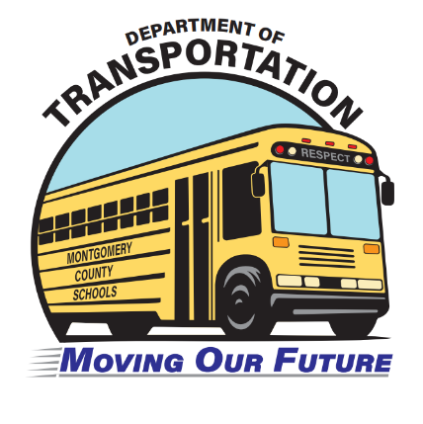

What You Should Know About Riding the Bus

Montgomery County Public Schools (MCPS) provides bus service for:
- Elementary school students living more than 1 mile of walking distance from the school. *
- Middle school students living more than 1.5 miles of walking distance from the school. *
- High school students living more than 2 miles of walking distance from the school. *
- Students who face hazardous walking conditions regardless of distance from school (multilane highways, construction areas, etc.) as determined by the MCPS Department of Transportation.
- Students in special education, magnet, gifted/talented, and some vocational/education programs that are not offered at the student’s home school.
*A tenth of a mile may be added to establish a reasonable boundary.
Students
Students are responsible for their behavior and self-control on the bus and at bus stops at all times. Disorderly students can threaten the safety of all riders by distracting the bus operator making the bus ride to and from school an unpleasant and even intimidating experience for other students. Students are expected to obey the instructions of the bus operator just as they would follow instructions of teachers and school administrators.
Parents
Parents can help further the safety of all students by making sure their children know the bus rules and etiquette that help ensure safe, orderly, and pleasant bus trips. For elementary and middle school students, it is recommended that a parent or other adults wait at the bus stop with the students to monitor and supervise their behavior and help with any problems, such as a late bus.
Many routes are designed so that students do not need to cross a major roadway to use the bus. This is indicated on route descriptions by “RSO” (right side only) next to the bus stop notation. Parents should not allow their children to circumvent this safety measure by crossing the road to use a different bus stop if there is one on their side of the street. Parents should contact their depot manager if no bus stops on their side of the street.
The Community
Parents/guardians are responsible for their children on the way to the bus stop, at the bus stop, and on the way home from the bus stop. Children should arrive at their bus stop at least 5 minutes before the established pick-up time. Parents/guardians are responsible for their children once they arrive at the afternoon bus stop and should plan to meet the bus or arrange for a caretaker or other responsible adult to accompany the children safely home or to the child care provider. Parents/guardians should instruct their children where to get off the bus and familiarize them with unique aspects of the bus stop or landmarks so that, prior to the first day they will ride the bus, the children will clearly know the stop where they should get off the bus.
Please note: Bus operators do not know all of the possible caretakers who might be picking up a student on a particular day, and are unable to match each child with a specific adult. When students get off the bus, they are entirely in the care of the parent/guardian or other caregiver. They are on their own to walk home if no parent/guardian or caregiver is present.
If you usually meet your child at the bus stop and cannot make it on a given day, call the school well before dismissal time and ask that your child be kept at school to be picked up rather than placed on the bus at the end of the school day.
The kindergarten teacher will discuss bus safety in detail during the first week of school. Following safety rules when boarding, riding, and getting off the bus is very important. Reviewing safety rules with your child will help to ensure bus safety.
If you want your child to be supervised by an adult while walking home from the afternoon bus stop, we recommend the following:
- Plan for you or another caregiver to be at the bus stop ahead of the normal drop-off time, as the bus may arrive early on any given day.
- Plan in advance for another adult who is normally at the bus stop to care for your child if you are not there.
- If you have an emergency and cannot make it to the bus stop, call the school well before dismissal time, so your child will be kept at school for pickup rather than put on the bus. Be sure you always have the school phone number with you in case of the emergency.
- Be sure your child knows and can identify the proper bus stop and understands not to get off the bus at any other stop.
- Arrange for an older student “buddy” to walk home with your child, or allow your child to stay at the older student’s house until you are able to pick up your child. Be sure to work with the other student’s parent/guardian when arranging this plan.
- Be sure your child knows to tell the bus driver, before getting off the bus, if something is “not right.” This includes a parent/guardian or caregiver who is usually at the stop not being visible; missing the stop; or getting on the wrong bus and not recognizing any stop or familiar adults.
Once the student gets off the bus, only you can ensure your child is appropriately supervised.
At the bus stop, students are expected to:
- Arrive 5 minutes before the scheduled time.
- Maintain an orderly line in preparation to board the bus promptly, without shoving or pushing.
- Stay out of the roadway.
- Be considerate of nearby yards, driveways, houses, buildings, and private property.
- Move toward the bus only after it stops and the driver has signaled that it is safe.
On the bus, students are expected to:
- Behave appropriately, just as if they were in a classroom.
- Keep the aisle and emergency door clear of obstructions.
- Keep their arms, feet, and head inside the bus at all times.
- Be seated and make room for others to sit as well. Once ridership has been adjusted at the beginning of the school year, standing is not permitted.
- Discard trash in appropriate containers.
On returning home, students are expected to:
- Walk 10 feet in front of the stopped bus, if they must cross the road, and only cross after the bus operator has indicated that it is safe.
- Refrain from trying to direct traffic upon leaving the bus.
At all times, students may not:
- Bring animals, alcohol, drugs, tobacco, weapons, glass containers, or explosives on the bus.
- Use vulgar language or gestures, fight, or engage in sexual harassment or other improper and/or illegal conduct.
- Throw any papers or objects in the bus or out the windows.
- Operate the emergency exits without permission unless it is an emergency.
- Smoke, drink, eat, or play radios without headphones.
- Damage or deface any part of the bus.
- Ride a different bus than the one they have been assigned to, unless they have written permission from a parent and permission from the principle.

