Col. Z. Magruder High School
Honors Human Anatomy and Physiology
Introduction: Anatomical Vocabulary Lab

Objectives:

• Describe the principal body systems and identify the major organs that comprise them.
• Define the regional names and external features of the body.
• Describe the directional terms used in discussing the body.
• Identify the various planes used in describing the body.
• Identify the various locations and linings of the body cavities

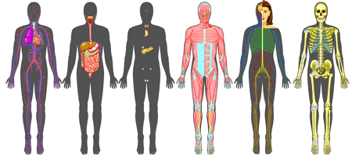

Strategy:

1. Test your knowledge by completing Activity 1.
2. Use the introductory packet to complete
Activities 2-4 and 6.
3. Try Activity 12!
4. Other activities will be completed in class.

Dr. Newman 1

Vocabulary: Regional vocabulary to know.

acromial antebrachial antecubital axillary brachial buccal calcaneal carpal cephalic cervical costal

cranial crural
digital/phalangeal dorsal
facial
femoral frontal gluteal inguinal lumbar

mammary mental nasal olecranal occipital oral
orbital/ocular otic
palmar
patellar

pedal plantar popliteal pubic sternal sural thoracic vertebral umbilical

Vocabulary: Body organs and structures to know location.

brain
skull
spinal cord spine esophagus
trachea
thyroid larynx sternum

clavicle pelvis
coccyx femur tibia
lungs heart
diaphragm liver
stomach
stomach
small intestine
large intestine (colon)
kidneys
ovaries
testes

Vocabulary: Directional terms.

anterior cephalic contralateral cranial

deep distal dorsal external inferior

intermediate internal ipsilateral lateral
medial

posterior proximal superficial superior ventral

Vocabulary: Planes through body, abdominopelvic regions and quadrants.

Sagittal/midsagittal frontal/coronal horizontal/transverse

Vocabulary: Body cavities

dorsal cavity brain cavity spinal cavity ventral cavity thoracic cavity
abdominopelvic cavity

pericardial cavity pleural cavity mediastinum abdominal cavity pelvic cavity

serous cavity visceral layer parietal layer serous fluid pericardium

peritoneum

Activity 1 (Matching): Use the lettered choices for both Activities 1a and 1b. For each of the numbered statement, write the letter of the body system that best fits the description.

(A) Cardiovascular system
(B) Digestive system
(C) Endocrine system
(D) Integumentary system
(E) Lymphatic system (F) Muscular system (G) Nervous system
(H) Reproductive system
(I) Respiratory system
(J) Skeletal system
(K) Urinary system

Activity 1a Activity 1b

1.

2.

3.

4.

5.

6.

7.

8.

9.

10.

11.
Regulates body activities and re- sponds to changes in the internal and external environments by us- ing electrochemical impulses. Regulates body activities by using chemical messengers such as hormones.
Breaks down large food molecules into smaller molecules that are easily absorbed.
Produces gametes.

Eliminates nitrogenous wastes and regulates the chemical com- position of blood.
Senses and protects the body from the external environment,
and helps in the regulation of body temperature.
Returns excess tissue fluid back to the blood and is involved in im- munity.
Supports and protects the body, and provides the framework which muscles use to move the body. Exchanges oxygen and carbon dioxide between the air and the blood.
Produces body movements and generates heat.
Transports nutrients and oxygen to the tissues and waste and car- bon dioxide away.
1.

2.

3.

4.

5.

6.

7.

8.

9.

10.

11.
Pituitary gland, thyroid, and pancreas.

Pancreas, stomach, and intes- tines.

Heart, arteries, and veins. spleen, thymus.
Biceps, trapezoid, deltoid. Testes, ovaries, uterus. Kidneys, ureter, and urethra. Lungs, bronchi, and trachea. Femur, radius, and scapula. Brain and spinal cord.
Skin, sweat glands, touch re- ceptors.

Activity 2 (Matching): For each of the numbered common body regional name, write the letter of the anatomical adjective from the list below that best describes it.

(A) (B) | acromial antebrachial | (N) (O) | dorsal facial | (AA) (BB) | orbital/ocular otic
(C) | antecubital | (P) | femoral | (CC) | palmar
(D) | axillary | (Q) | frontal | (DD) | patellar
(E) | brachial | (R) | gluteal | (EE) | pedal
(F) | buccal | (S) | inguinal | (FF) | plantar
(G) | calcaneal | (T) | lumbar | (GG) | popliteal
(H) | carpal | (U) | mammary | (HH) | pubic
(I) | cephalic | (V) | manual | (II) | sternal
(J) | cervical | (W) | mental | (JJ) | tarsal
(K) | coxal | (X) | nasal | (KK) | thoracic
(L) | cranial | (Y) | olecranal | (LL) | umbilical
(M) | digital/phalangeal | (Z) | oral | (MM) | vertebral

1.
face
14.
hand
27.
ankle

2.
thigh
15.
palm of hand
28.
buttocks

3.
neck
16.
arm pit
29.
breastbone

4.
head
17.
navel
30.
lower arm

5.
groin
18.
cheek
31.
fingers/toes

6.
chin
19.
foot
32.
pubis

7.
back of elbow
20.
forehead
33.
shoulder

8.
front of elbow
21.
knee cap
34.
ear

9.
wrist
22.
sole of foot
35.
hip

10.
lower back
23.
skull
36.
breast

11.
upper arm
24.
chest
37.
nose

12.
back of knee
25.
eye
38.
spine

13.
heel
26.
mouth
39.
back

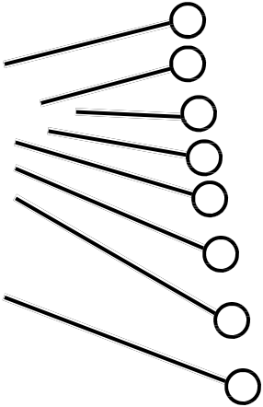
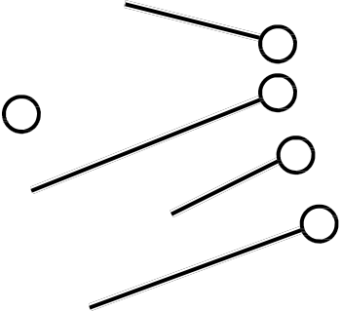
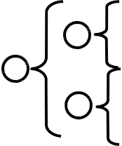
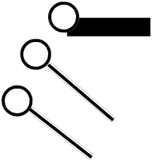
Activity 3 (Diagram of anterior body regions): For each numbered ana- tomical term, write the letter or number from the diagram that best fits its location.

1. abdominal
4 A
2. antebrachial B
5
3. antecubital
C
4. axillary 3
D
5. brachial
E
6. buccal 2
7. carpal 1 F
8. cephalic G
9. cervical
10. coxal Z H
11. cranial I
12. crural Y J
13. facial 6
K
14. femoral
15. frontal X L
16. inguinal W
7
17. mammary V
18. manual
19. mental
M
20. nasal
21. oral U
22. orbital
23. otic
24. palmar
T N
25. patellar
26. pedal
S
27. pelvic
28. phalangeal (hand) R
29. phalangeal (toes)
30. pubic Q
31. sternal P O
32. tarsal
33. umbilical Copyright © John Wiley & Sons.

Activity 4 (Diagram of posterior body regions): For each numbered ana- tomical term, write the letter from the diagram that best fits its location.

1.

2.

3.

4.

5.

6.

7.

8.

9.

10.

11.

12.

13.

14.
acromial

calcaneal A
cephalic cervical
B
gluteal M

lumbar

manual L

olecranal
K
plantar

popliteal J
sacral

scapular
I N
sural

vertebral

C

H

G

F

E

Copyright © John Wiley & Sons. D

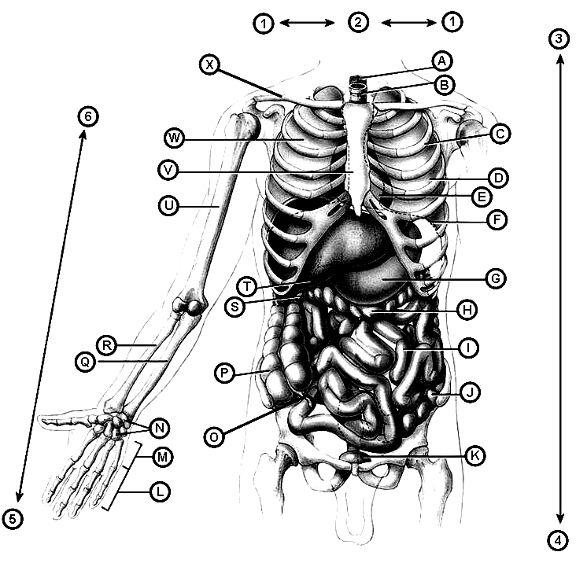
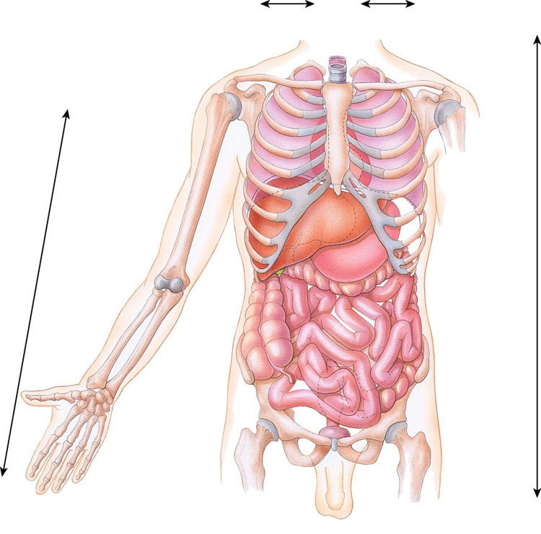
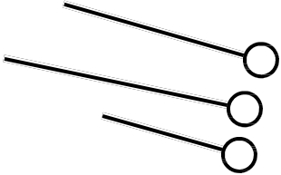
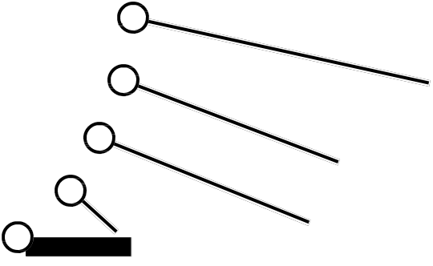
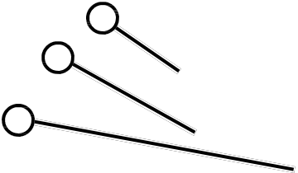
Activity 5 (Diagram of general body anatomy): For each numbered state- ment below, write the letter or number from the diagram that best fits it.

1 2 1
3
A X
B
W

6
V C

U

D T
E

S F

R
G Q
H
P
I

J N O
K M

L
5

4

Copyright © John Wiley & Sons.

1.
2.
3.
4.
5.
6.
7.
8.
9.
10.
appendix ascending colon carpals
clavicle descending colon diaphragm esophagus
gall bladder heart humerus
11.
12.
13.
14.
15.
16.
17.
18.
19.
20.
left lung liver metacarpals phalanges radius
rib
right lung
small intestine sternum stomach
21.
22.
23.
24.
25.
26.
27.
28.
29.
30.
trachea transverse colon ulna
urinary bladder distal inferior/caudal lateral
medial proximal superior/cephalic

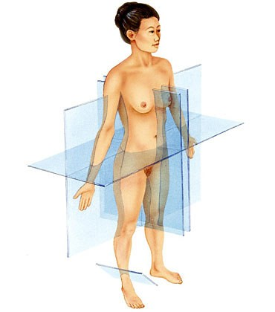
Activity 6 (Diagram of planes through body): For each numbered body plane, write the letter from the diagram that fits it.

A

D

B

C

E

Copyright © John Wiley & Sons.

1.

2.

3.

4.

5.
frontal/coronal plane midsagittal plane oblique plane parasagittal plane transverse plane

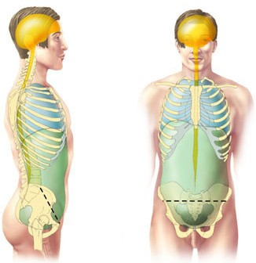
Activity 7 (Diagrams of body cavities): For each numbered term, write the letter from the diagram that best fits its location.

A

B

C

D

E

F

Copyright © John Wiley & Sons.

1.

2.

3.
abdominal cavity spinal cavity diaphragm
4.

5.

6.
thoracic cavity pelvic cavity brain cavity

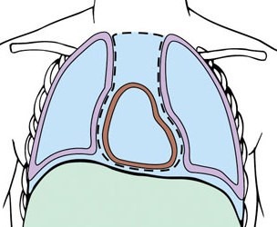
Activity 8 (Diagram of body cavities and membranes): For each num- bered term, write the letter from the diagram that best fits its position.

I

H

F A G

B

E

D C

Copyright © John Wiley & Sons.

1.

2.

3.

4.

5.

diaphragm mediastinum
right pleural cavity left pleural cavity parietal pleura
6.

7.

8.

9.
visceral pleura pericardial cavity parietal pericardium visceral pericardium

Activity 9 (Diagram of abdominopelvic regions): For each numbered term, write the letter from the diagram that best fits it.

A
E

B C D

F
G H I

J

K L M

Copyright © John Wiley & Sons.

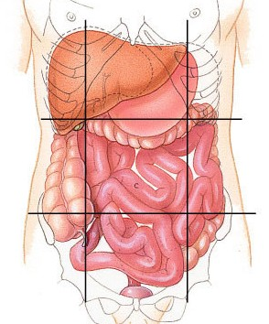
1.

2.

3.

4.

5.

6.

7.
epigastric region hypogastric region
left hypochondriac region left inguinal (iliac) region left lumbar region
left midclavicular line

right hypochondriac region
8.

9.

10.

11.

12.

13.
right inguinal (iliac) region right lumbar region
right midclavicular line subcostal line transtubercular line umbilical region

Activity 10 (Diagram of abdominopelvic quadrants): For each numbered quadrant, write the letter from the diagram that fits it.

A B

C D

Copyright © John Wiley & Sons.

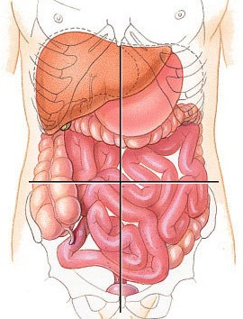
1.

2.

3.

4.
left lower quadrant left upper quadrant right lower quadrant right upper quadrant

Activity 11 (Matching/Multiple Choice): For each numbered organ or structure, write the letter of the abdominopelvic region, the quadrant, and the body cavity where it belongs. Do not answer the cells that are shaded.

Abdominal Regions
(A) epigastric
(B) hypogastric
(C) left hypochondriac
(D) left inguinal
(E) left lumbar
(F) right hypochondriac
(G) right inguinal (H) right lumbar (I) umbilical
(J) Not in any region
Abdominopelvic Quadrants
(A) left lower quadrant (B) left upper quadrant (C) right lower quadrant (D) right upper quadrant (E) Not in any quadrant
Body Cavities
(A) brain (B) spinal (C) pleural
(D) pericardial (E) abdominal (F) pelvic
(G) Not in any cavity

 |  | Region | Quadrant | Cavity
1. | spleen
2. | appendix
3. | urinary bladder
4. | gall bladder
5. | most of liver
6. | uterus
7. | most of stomach
8. | most of ascending colon
9. | rectum
10. | navel
11. | thyroid
12. | pituitary gland
13. | left ovary
14. | heart
15. | right lung

Activity 12 (Multiple Choice Questions): In the space provided, write the letter of the choice which best answers the question or completes the statement.

1. The directional term that describes the nose relative to the eyes is: [A] medial; [B] distal; [C] superficial; [D] anterior; [E] lateral.

2. The directional term that describes the antebrachial region relative to the brachial region is: [A] anterior; [B] ventral; [C] proximal; [D] distal;
[E] both A and B are correct.

3. The directional term that describes the spleen relative to the left kidney is:
[A] superior; [B] cephalic; [C] medial; [D] lateral; [E] both A and B are correct.

4. The directional term that describes the right kidney relative to the left kidney is: [A] contralateral; [B] ipsilateral; [C] medial; [D] cephalic; [E] intermediate.

5. The directional term that describes the index finger relative to the ring finger is: [A] distal; [B] proximal; [C] medial; [D] lateral; [E] intermediate.

6. The directional term that describes the trachea relative to the esophagus is:
[A] anterior; [B] ventral; [C] superficial; [D] posterior; [E] A, B, and C are correct.

7. The directional term that describes the radius bone relative to the ulna is: [A] distal; [B] proximal; [C] medial; [D] lateral; [E] superior.

8. The membrane that covers the wall of the abdominal cavity is the: [A] pleura; [B] perineum; [C] peritoneum; [D] pericardial; [E] mediastinum.

9. The membrane that covers the heart itself is the: [A] parietal pericardium;
[B] visceral pericardium; [C] mucous pericardium; [D] mediastinum; [E] pleura.

10. The membrane that covers the cavity that holds the heart is the:
[A] parietal pericardium; [B] visceral pericardium; [C] mucous pericardium; [D] mediastinum; [E] pleura.

