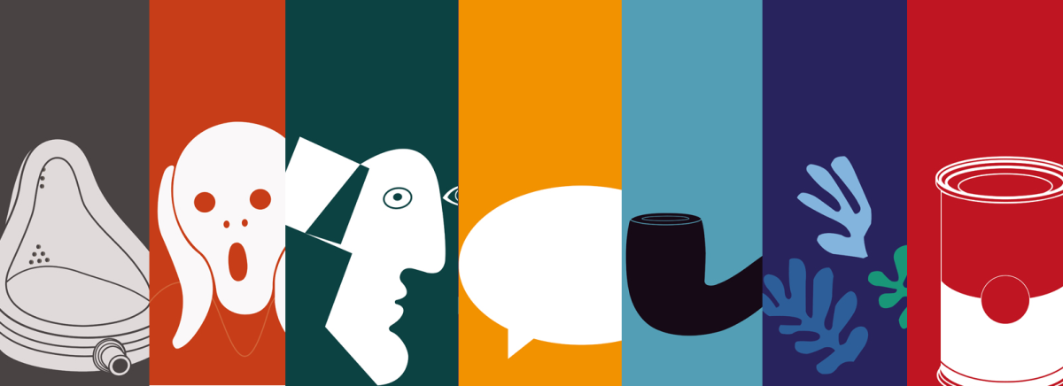
Visual Art Course Offerings:
Digital Photography 1 (9th-12th)
*Advanced Digital Photography 2 (10th-12th)
*AP 2D Design (AP Photo) (11th & 12th)
2-D Studio Art 1 (9th-12th)
*Advanced 2-D Studio Art 2 and/or Advanced Drawing A & Advanced Contemporary Mixed Media B (10th-12th)
*AP Drawing (Drawing & Painting) (11th & 12th)
Ceramics & Sculpture 1 (9th-12th)
*Advanced Ceramics & Sculpture 2 (10th-12th)
*AP 3D Art (AP Ceramics & Sculpture) (11-12th ^{grade})
National Art Honor Society:
1 credit (year) of any Visual Art class to be eligible to apply.
2.5 credits of Art by graduation, including at least 1 upper-level course.
Adv Visual Art Pathways Certificate:
Earn an Advanced Art Certificate by completing one of the above color-coded pathways.

Email Mrs. Heaton with any questions - Shannon_M_Heaton@mcpsmd.org
*Prerequisite of at least one semester in level 1 class

